Project Summary
2015 DTC Task MM5: Test of an Expanded WRF-ARW Domain

Trevor Alcott
Ligia Bernardet
Isidora Jankov

1. Introduction

The High-Resolution Rapid Refresh (HRRR) model represents a major step forward in the operational prediction of severe thunderstorms and mesoscale convective systems as well as other year-round mesoscale phenomena. It became operational at NCEP on 30 September 2014, after extensive real-time evaluation by forecasters at NCEP’s Aviation Weather, Storm Prediction and Weather Prediction Centers (AWC, SPC and WPC), as well as by the Federal Aviation Administration. In addition to the original purpose to improve prediction of warm–season convection and its impact on the National Aerospace System, the HRRR has found wide acceptance by forecasters in and out of the National Weather Service as guidance for a variety of weather phenomena in all seasons, including East Coast winter storms, winter precipitation type, timing and intensity of heavy non-convective and convective precipitation, land-falling tropical cyclones, and hub-height wind trends for the renewable-energy industry.
The HRRR uses the ARW dynamical core and a physics package (under continued active development) that has proved effective in capitalizing on the cloud-permitting resolution of the model. The Earth Modeling Branch of ESRL-GSD has developed unique initialization procedures using radar and satellite as well as conventional in-situ observations together with a 1-h Rapid Refresh (RAP) forecast. These are continually being improved to achieve much better forecast accuracy at very short lead times of 1-3 h. The HRRR currently uses lateral boundary conditions provided by the previous hour’s RAP forecast.
As computing resources at NCEP continue to increase in coming years, we foresee that the current regional models, the NAM and RAP, will be replaced (within 5-7 years, perhaps sooner) by regional cloud-resolving configurations of similar domain size to that of the current NAM and RAP. These will be nested within the then operational global model.
Looking toward that day, and in view of the importance of accurate short-term forecasts for vulnerable coastal areas, particularly along the Gulf and Atlantic coasts, we investigated the value of an initial expansion of the HRRR domain in all directions, but mainly toward the east and south. Coastal storms (aka Nor’easters) that impact the heavily populated east coast with high winds, heavy precipitation, and often a very disruptive “wintry mix” of precipitation are often close enough to the current lateral boundaries of the HRRR, particularly during their formation and deepening stages in the Gulf of Mexico and in the southwest North Atlantic between the southeast US and Bermuda, and as they pass seaward of New England as they track north or northeastward, that the circulation is not well described within the model domain itself. The lateral boundaries of the HRRR domain are often within the storm circulation, leading to flow distortions. Such an expanded domain would also allow for improved prediction of tropical systems that are within, say, 48-h striking distance of the US mainland. At the time this work was originally proposed, the operational NCEP HRRR forecasts only extended to 15 h, but owing to considerable interest on the part of forecasters within and outside of the NWS to see an extension of the HRRR, ESRL is now running the HRRR experimentally to 36 h, every 3 hours. Expanding the boundaries of the current HRRR domain has thus become increasingly important for these longer forecast lengths.

2. Project Deliverables
- Upgraded procedures for initialization of convection permitting models over ocean areas prone to deep convection, mesoscale convective systems and tropical cyclones.
- Recommendation for domain configuration and physics suite for expanded HRRR using ARW.

3. Data and Methods

Three tropical cyclone case studies were conducted with HRRR version 2 (HRRRv2), which is the version implemented operationally at NCEP in August 2016. HRRRv2 uses the WRF-ARW dynamic core version 3.6.1, with Thompson aerosol-aware microphysics, modified versions of the MYNN planetary boundary layer and RUC land surface schemes, and the RRTMG shortwave and longwave radiation schemes. No convective parameterization is used. All simulations were run with a horizontal grid spacing of 3 km and forecast length of 36 h, with a 1-h pre-forecast period during which MRMS radar reflectivity was assimilated in 15-minute steps. At hour 0, conventional and satellite observations were assimilated using GSI. RAP 3-39-h forecasts provided initial and boundary conditions.
The extended domain used in our experiments (Fig. 1) reflects a primary interest in improved forecasts of tropical cyclones, a goal modified somewhat from our original intent for the reasons stated below. In all experiments, the domain was extended 1050 km east and 900 km south of the real-time HRRRv2 CONUS domain (2150x1360 vs 1800x1060 grid points, or an approximate 53% increase in area).
Our original plan was to choose several winter (i.e., Northeast U.S. coastal snowstorm) and summer (i.e., southeast U.S. tropical cyclone landfall) cases to test the sensitivity of HRRR forecasts to the size of the domain. However, we encountered a series of challenges that prevented us from conducting extended domain simulations for cases prior to May 2016.
Forecasts from an older (3 h previous) initialization of the 13-km Rapid Refresh (RAP) model provide boundary conditions for HRRR. Since the WRF pre-processing system (WPS) cannot read the native RAP data projected on a rotated latitude-longitude grid, the experimental and operational CONUS HRRR forecasts are initialized from RAP forecasts remapped to the 13-km Lambert-conformal NCEP grid number 130. The CONUS HRRR domain (as run experimentally at the time of writing at ESRL since 2011, and at NCEP since Sept 2014) is already nearly as large as NCEP grid number 130, and hence any significant expansion of the domain required one of the following:

- Added capability in WPS to read data projected on a rotated latitude-longitude grid
- Remapping of the native RAP rotated latitude-longitude data to a new grid compatible with WPS

After some communication with NCAR, it was determined that suitable improvements to WPS would not be made before the end of this project. Thus we moved on to option (2), which in turn presented some additional challenges:

- Performing retrospective runs of HRRR requires obtaining RAP forecasts from the High Performance Storage System (HPSS). Only post-processed RAP forecasts, and not the raw netCDF format “wrfout” files, are archived on HPSS. Prior to Feb 2016, this post-processing consisted of generating native, pressure and surface grids in GRIB-1 format, then converting to GRIB-2 format. Only the GRIB-2 files are archived on HPSS, on the native rotated latitude-longitude grid and the NCEP grid number 130. Thus the archived, native GRIB-2 data would need to be remapped to a grid both larger than the 130 grid, and compatible with WPS.
- Due to a persistent error with the GRIB1-to-GRIB2 conversion process, the archived GRIB-2 had missing and incorrect metadata. This issue rendered useless any remapping utilities such as wgrib2, and all attempts to correct the metadata issues failed. These issues were not fully resolved until May 2016. Therefore, there was no practical method of running extended domain HRRR case studies for dates prior to May 2016.
- Although WPS is intended to function on any grid with a compatible projection, a variety of projections are hard-coded based on starting latitude-longitude grid points, x- and y-dimensions, or other attributes. After performing a number of tests, we were unable to create a custom grid that, after running the metgrid.exe and real.exe scripts, produced initial and boundary conditions correctly projected on an extended HRRR domain.
- With no options for a custom grid, we chose an “official” grid nearest in size to the native RAP domain. This grid – NCEP number 221 – has a much larger grid spacing than the native RAP grid (32 vs. 13 km). Although the only practical path forward, this methodology introduces additional sensitivity to the grid spacing of the RAP forecasts. We controlled for this sensitivity by performing both standard and extended domain HRRR simulations using the same remapped RAP forecasts, but our results cannot be considered an exact test of the value of an extended HRRR domain initialized from native RAP forecasts. Such a test would ultimately require capability in WPS to directly read from the 13-km rotated latitude-longitude grids, a change that is currently in progress at NCAR at the time of writing.

Given that we were restricted to simulations of cases between May 2016 and the termination of project funding in Sep 2016, we were fortuitously provided with several tropical cyclones that formed and/or intensified near the boundaries of the current HRRR domain. We chose to examine three of these storms, with model initialization times chosen such that the center of each storm was near or slightly outside the standard domain but well inside the extended domain. The storms and initialization times of interest were: Bonnie (12 UTC 27 May 2016), Colin (00 UTC 6 Jun 2016) and Hermine (12 UTC 31 Aug 2016).
Extended domain simulations were also conducted for Hurricane Hermine, with and without lightning data assimilation, to a forecast length of 36 h. Hermine was chosen based on the large number of lightning strikes occurring in an area of relatively low simulated reflectivity values at model initialization time (Fig. 3). Five-minute accumulated strike counts for the hour prior to model initialization were obtained from the global GLD-360 dataset, then summed to produce four, 15-minute counts. The 15-min counts were then converted to 3-D reflectivity profiles, to which we assigned temperature tendencies in the same manner as for WSR-88D radar reflectivity. The temperature tendency values assimilated during the 1-hour HRRR pre-forecast were then calculated as the point-based maximum of the lightning- and WSR-88D radar-derived tendencies. Thus positive lightning strike counts were used to add latent heating in areas without radar coverage, but zero lightning counts in areas with radar coverage were not used to remove radar-derived latent heating. This methodology is currently in use in the experimental ESRL and operational NCEP RAPv3 systems.

4. Results

A. Bonnie
Tropical Storm Bonnie was a relatively weak storm that never reached hurricane intensity, but produced significant rainfall over South Carolina when it made landfall. Both CONUS and extended domain (hereafter, ETX) simulations of Bonnie moved the storm too quickly and too far north, with EXT exhibiting slightly larger track errors (Fig. 4). EXT however produced a slightly more accurate forecast of minimum central pressure (1009 vs 1010 hPa when 1009 hPa was observed). Bonnie was therefore an unfortunate case when neither CONUS nor EXT simulations were able to produce an accurate track forecast, with EXT providing only a very slight improvement in intensity.

B. Colin
Tropical Storm Colin also failed to reach hurricane intensity, but brought heavy rainfall to the Florida Panhandle. At initialization time (00z 6 Jun 2016), Colin was approximately bisected by the southern edge of the CONUS domain, making this storm an ideal test of the potential for domain extension. However, both CONUS and EXT simulations moved the storm too slowly to the northeast (Fig. 5). By hour 36, the observed center of Colin was located on the northeastern South Carolina coast. The CONUS run kept the storm center west of Florida at this time, but EXT had at least brought the storm over mainland Florida. EXT also produced a much better simulation of 36-h total precipitation, removing the erroneous 200-400-mm local maximum that was present in the CONUS run. Since heavy rainfall was the primary impact of this storm, EXT provided a substantial and useful forecast improvement over the CONUS domain.

C. Hermine
Hurricane Hermine was the strongest of the tropical cyclones tested, bringing high winds and heavy rainfall to Florida, Georgia and the Carolinas. As in the Colin experiments, an initialization time was chosen where Hermine was approximately bisected by the southern edge of the CONUS domain. Both CONUS and EXT simulations brought the storm too far west, but EXT showed some significant improvements over CONUS (Fig. 6). Although too slow in both experiments, the track in EXT was much closer to the actual path of Hermine than in the CONUS run. The 36-h CONUS forecast for Hermine was much too weak, both in terms of sustained winds (55 kt vs 70 kt observed) and minimum central pressure (991 hPa vs. 983 hPa observed). EXT forecast values were nearly identical to observations, save for a slight overestimate of minimum central pressure (980 vs. 983 hPa observed). Thus although neither simulation provided accurate timing for Hermine, EXT was a clear winner both in terms of track and intensity. For a hurricane about to impact the US mainland, this was clearly a case where a domain expansion would have been highly valuable.

D. Hermine, with and without lightning DA
The overall impact of lightning data assimilation was small, but positive, in extended-domain Hermine simulations initialized at 12 UTC 31 Aug 2016. Minor differences were noted in the initial simulated composite reflectivity field (Fig. 7). By 36 h into the forecast (valid 00 UTC 2 Sep), both simulations are too slow and too far west with Hermine, but lightning DA yielded a reduction in forecast track error relative to the control simulation, from 155 km to 138 km. Based on forecast 10-m wind speeds, the control simulation showed some overintensification of Hermine that was not evident when using lightning DA. Based on National Hurricane Center advisories, Hermine displayed a very asymmetric wind field at 00 UTC 2 Sep (i.e., with 50-kt sustained winds extending 275 km to the southeast, and only 110 km to the northwest). The simulation with lightning data assimilation much better captured this asymmetry.

5. Conclusions

For the three tropical cyclone cases examined, the overall impact of an extended domain ranged from slight (Bonnie) to significant (Hermine) improvement. Although not shown, differences between CONUS and EXT simulations were typically small for the first 6-12 h, then began to grow larger after hour 12. There was no evidence of a degradation of forecast skill in any of the EXT case studies, relative to the current CONUS domain.
The results of these experiments, particularly those for Hermine, suggest significant forecast value in an expansion of the HRRR domain to the south and east. Prompted by these results, and further motivated by pending expansion of the NDFD forecast grids, and desire to cover the full area of the Real-Time Mesoscale Analysis (a verification dataset for NWS forecasts and operational models), GSD has planned an expansion of the experimental ESRL HRRR forecast grid (Fig. 8), thus addressing project deliverable number 2. The mismatch in domains between the proposed expansion and the work conducted in this study reflects additional factors such as other operational systems (e.g., RTMA), an unexpected increase in computing resources that arrived in summer 2016, and a desire to improve forecasts in regions beyond the southeast US and Caribbean. Early results from the real-time extended domain tests are already encouraging, such as the 36-h EXT forecasts for Hurricane Matthew (Fig. 9), which correctly predicted Matthew would not make landfall in Florida.
Results of the sensitivity tests to lightning data assimilation also prompted action in GSD, and the lightning reflectivity proxy algorithm now in real-time RAPv3 will soon be incorporated into the experimental HRRRv3, for eventual implementation at NCEP. This outcome therefore addresses project deliverable number 1, i.e., an upgraded procedure for initialization of convection permitting models over ocean areas prone to deep convection, mesoscale convective systems and tropical cyclones.
The results of this study have thus helped to accelerate several model development efforts within GSD, as we work toward implementation of a new and improved HRRRv3 system at NCEP in 2018.

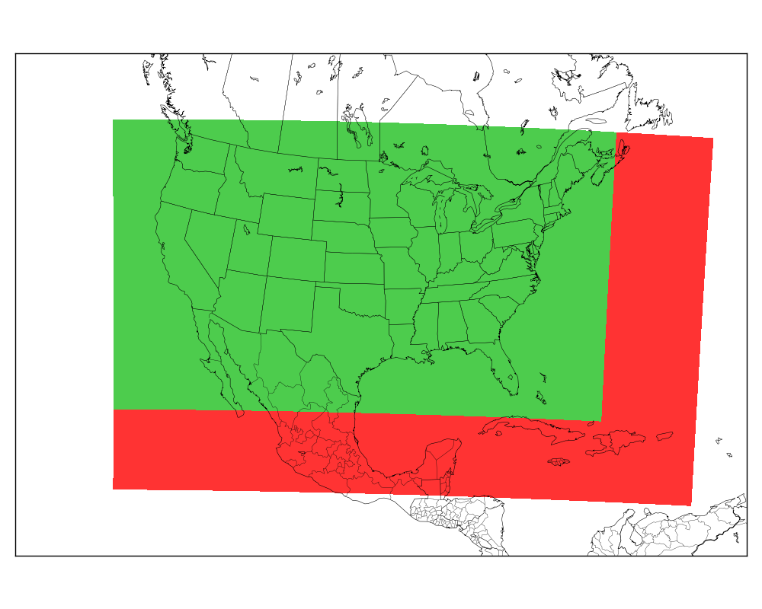

Fig. 1. HRRR CONUS domain (green) and extended domain used in sensitivity tests (red).

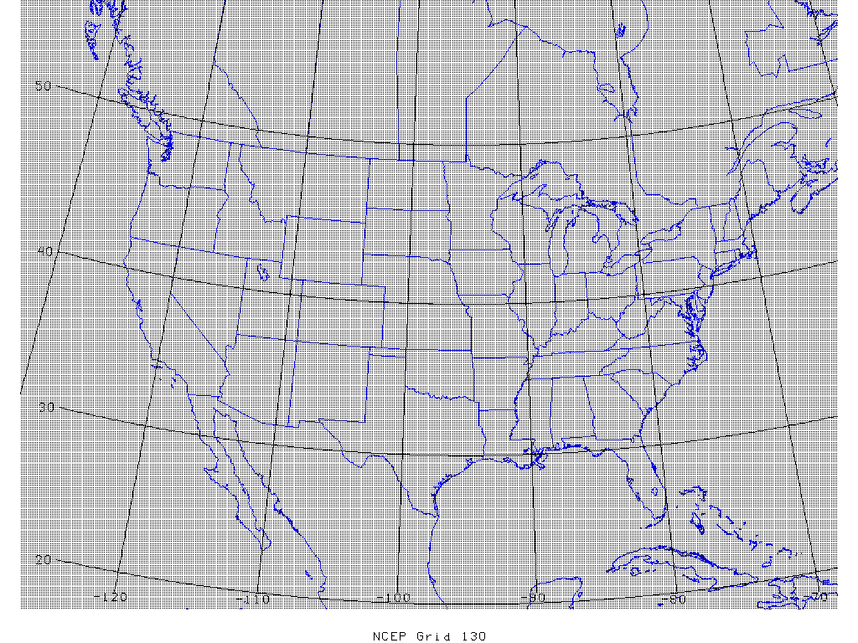

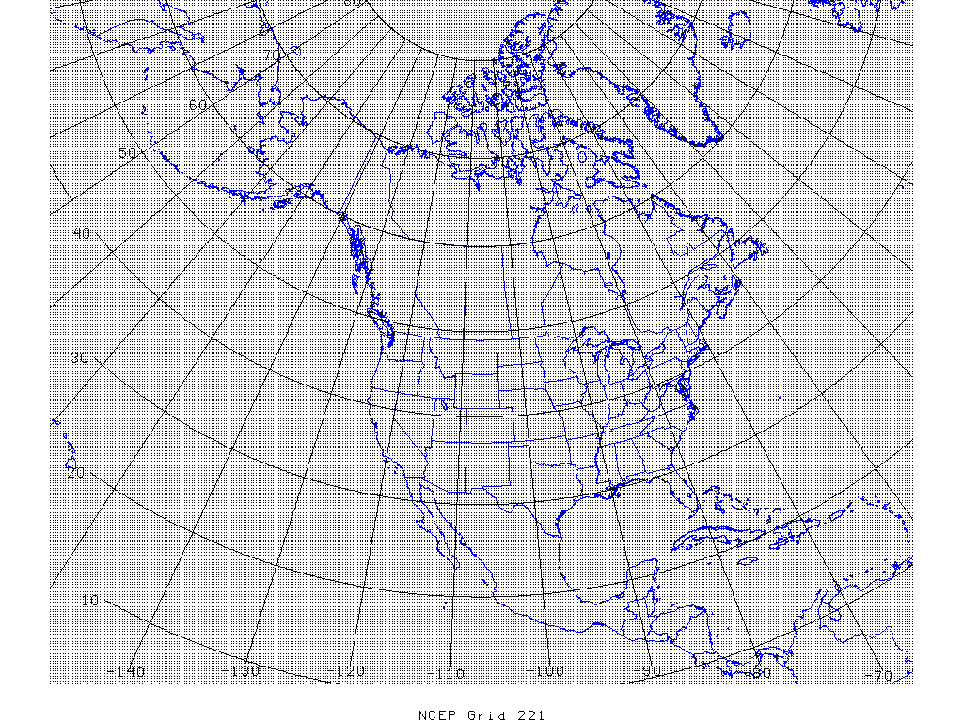

Fig. 2. NCEP grid numbers 130 (top) and 221 (bottom).

Fig. 3. GLD360 lightning strikes during the pre-forecast hour of Bonnie (left), Colin (center) and Hermine (right). For context, 0-h forecast composite reflectivity from extended domain simulations included in lower panels.

Fig. 4. HRRR CONUS and extended domain simulated composite reflectivity forecasts of tropical storm Bonnie, with NHC Best Track indicated by dashed red line and current position by large red dot. NHC pressure/winds valid at simulation end time.

Fig. 5. HRRR CONUS and extended domain simulated composite reflectivity forecasts of tropical storm Colin, with NHC Best Track indicated by dashed red line and current position by large red dot. Accumulated 36-h precipitation forecasts compared to Stage-IV QPE analyses in bottom panels. NHC pressure/winds valid at simulation end time.
Fig. 6. HRRR CONUS (left) and extended domain (right) simulated composite reflectivity forecasts of tropical storm Hermine, with NHC Best Track indicated by dashed red line and current position by large red dot. Instantaneous 80-m wind speed forecasts in bottom panels. NHC pressure/winds valid at simulation end time.
Fig. 7. HRRR extended domain simulated composite reflectivity forecasts of tropical storm Hermine, with (left) and without (right) lightning data assimilation. NHC Best Track indicated by dashed red line and current position by large red dot. Instantaneous 80-m wind speed forecasts in bottom panels. NHC pressure/winds valid at simulation end time.

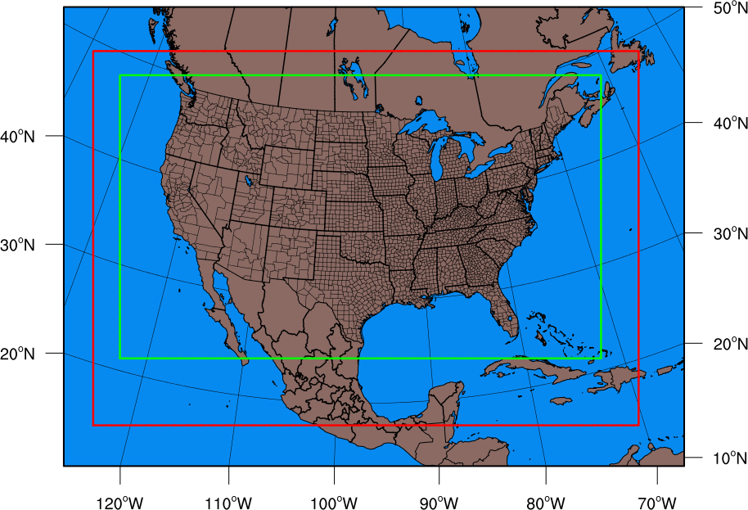

Fig. 8. Extended domain (red outline) planned for experimental, real-time HRRR runs beginning late 2016 or early 2017. Current CONUS domain in green outline for comparison.

Fig. 9. Experimental, real-time extended domain test for Hurricane Matthew, using the domain shown in Fig. 8. 33-hour simulated composite reflectivity forecasts initialized 15 UTC 5 Oct 2016 and valid 00 UTC 7 Oct, with regional reflectivity mosaic valid 0000 UTC 7 Oct.

